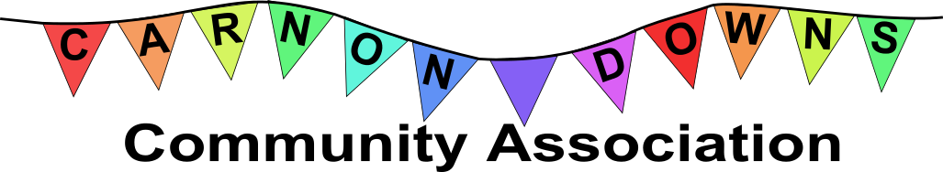
2019 Village Autumn Show
Saturday 14th September 2019 - Carnon Downs Village Hall
Schedule and Entry Form
Timetable
8.30am – 10.30am Staging of Exhibits
10.30am – 2.00pm Administration and Judging of Exhibits
2.00pm - Show opens to the Public, Refreshments will be available, Entry fee by Donation to the Carnon Downs Community Association
4.00pm – Prize Giving. Exhibits and Certificates may then be removed
5.00pm - Hall closes, all exhibits need to be collected by then
Rules
No entry will be accepted without the 25p entry fee per exhibit
Only one entry per class per exhibitor is allowed
All entries must be the exhibitors own work and must not have been exhibited at a previous Carnon Downs Village Show.
All entries must be received by 7pm on Monday 9th September 2019
CDCA committee reserves the right to refuse an entry
The decision of the judges shall be final
Although every care will be taken to safeguard exhibits, the committee will not be responsible for losses or damage.
Upon arrival for staging, all entries will be given a unique reference number to be displayed, the name of the exhibitor should not be visible until after judging has been completed.
Winning exhibits will receive a certificate; children’s entries will receive prize money of £1 for 1st, 50p for 2nd and 20p for 3rd place. There will also be an award for the “Best in Class” exhibit in each class.

Show classes
Children’s
Will be judged in 3 age groups, based on age on the day of the show;
a) Under 5’s b) Age 6 to 8, c) Age 9 to 12.
- An animal made from a vegetable
- A decorated cupcake
- A decorated egg
- A creature made out of recycled materials
- A lego creation, not from a kit
- A mini garden (no bigger than A4/ seed tray size)
- A Painted Pebble
- Tallest Sunflower – if not transportable to the village hall, judges will visit entries within the Feock Parish, to measure and photograph on Friday 13th September. Please ensure a telephone number is given to enable us to arrange this.

Cookery
- Vanilla Victoria Sandwich Cake (7inch/ 18cm tin, no fresh cream)
- A 2lb Loaf cake (e.g. tea/carrot/banana)
- A Medium Meat Pasty
- A White Loaf of Bread
- A Seasonal fruit pie
- Biscuits/cookies x 4
In the interest of hygiene, please leave all cookery exhibits covered. Judges will remove and replace the covers. Please label with key ingredients/flavourings.

Preserves
- A jar of Jam – any fruit
- A jar of Marmalade
- A jar of Chutney
- A jar of pickles – any vegetable
All should be homemade within the past 12 months and clearly labelled with key ingredients

Produce
- Beans, any climbing variety. Six on a plate
- Leeks, two of any variety.
- Tomatoes, any variety. Four on a plate
- Apples, any variety, eating or cooking. Four on a plate
- Autumn Fruit Bowl. Can be garden grown, hedgerow or a mixture.
- Any giant Vegetable.

Photography
- Bad plastic or plastic waste
- Waters edge or seashore
- All dressed up
- Animals and birds
- Kitchen utensils
- Ways to travel
Colour or Black and White, unmounted, maximum 7x5

Craftwork
- A crocheted garment
- A needlework item
- A knitted garment
- Patchwork/quilting
- A landscape painting in any medium (no larger than 16x20inches, 40x50cm)
- A piece of pottery or ceramics
Entries must have been produced in the past 12 months.

Flowers
- Autumn themed flower arrangement (max 12” wide)
- A potted cactus/succulent
- An arrangement of 3 seasonal homegrown flowers
- A Potted houseplant
- A Tied green garden foliage arrangement
- Tallest Sunflower – if not transportable to the village hall, judges will visit entries within the Feock Parish, to measure and photograph on Friday 13th September. Please ensure a telephone number is given to enable us to arrange this.

Adults fun/novelty
- A creature made out of recycled materials
- A misshapen vegetable
- An animal made from a vegetable
- A knitted/crocheted novelty item
2019 Village Autumn Show
Entry Form
Please submit by 7pm on Monday 9th September with the appropriate entry fee (20p per class) to; Bob & Caroline Richards St Kildas, Forth Coth, Carnon Downs, Tel: 01872 864567
Alternatively email: carnondownsvillage@gmail.com - we will send you the bank details to pay on line.
Name:
Contact Phone No or Email:
Class | Basic Description |  |  |  | Entry fee
Children’s Entries;
Name of Child |  | Age on Show Day |  | Class & Basic Description | Entry fee
Total Entry fee enclosed |  |  |  |  | £

Cookery classes only – please tick the box if you are happy for us to sell your cakes to raise funds for the Community Association when judging is completed.
I have read the rules and agree to comply by them.
Signed…………………………………………………………………..

